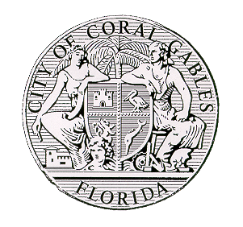 City of Coral Gables
Development Services Department
OVERTIME INSPECTION REQUEST
Mechanical and Fire approval required to schedule Smoke Test
Date: _______________ PERMIT # _______________________________
Company Name:__________________________________ Inspection Date/Time: ________________________________
Qualifier Name:___________________________________
Contact Name & Phone & E-mail address: _______________________________________________________________
Jobsite Address/Project Name: _________________________________________________________________________
Description of Inspection: _____________________________________________________________________________
Reason why an afterhours inspections is necessary: ________________________________________________________

______________________________________ __________________________________________________
Signature of Qualifier Print Name

------------------------------------------------------ FOR OFFICE USE ONLY ---------------------------------------------------------

Inspector Assigned _________________________________________

Inspector Assigned _________________________________________

Inspector Assigned _________________________________________

Inspector Assigned _________________________________________

Inspector Assigned _________________________________________

Commencement time is as stated on this inspection request form (WITHOUT EXCEPTIONS).
- Inspection area MUST be available/accessible at the approved time on this form.
- All necessary equipment, personnel, and staff must be on site/location.
- Fire alarm systems must be free of troubles & system normal status.
- Cancellations must take place by noon the business day before or all fees will be forfeited.
In accordance with City noise ordinance Sec. 34-124: start time is not before 07:00 hrs. If requirements are not met as stated above, the inspection will have to be reschedule and any associated fees will be applicable.

