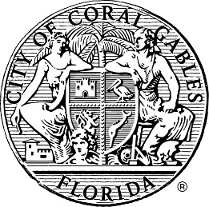
City of Coral Gables
Signature Hurricane Protection Program
List of Committed Providers

Program Providers

The following providers of impact windows and doors and installation services have committed to providing a twenty-five percent (25%) discount on impact windows and doors and installation services to eligible property owners. Providers wishing to be included on this list shall submit this inclusion request to Development Services setting forth their commitment to providing such discount. The City makes no representations whatsoever regarding any provider on the list, including their qualifications, workmanship, or pricing, other than representing that such provider has provided a written commitment stating that it will provide eligible property owners with a twenty-five percent (25%) discount. The inclusion of a provider on the list shall in no way be deemed or interpreted as an endorsement or recommendation by the City or any of its elected officials or employees of such provider or its services.

- Signature Impact Windows

